City of Coffs Harbour Economic Insight Report - December 2019

Welcome to the City of Coffs Harbour Economic Insights Report, an interactive resource for understanding the key metrics driving economic opportunity in the city. To create a complete picture of activity in the city, no one data set should be considered in isolation. Data is updated every quarter as it becomes available.

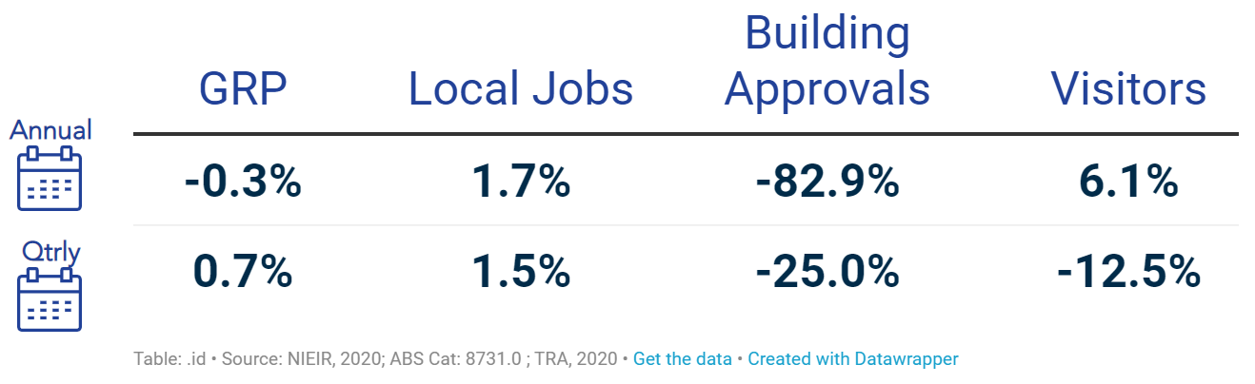

KEY INSIGHTS
- Local GRP in the City of Coffs Harbour was stronger in the December 2019 quarter than it was in the September quarter. Four quarter total GRP ($3612.1M) was lower than that generated in the four quarters to Dec 2018 due to a low Mar 2019 quarter.
- Local Job numbers also grew this quarter and were up compared to the same time last year too. The average local jobs number for the four quarters to City of Coffs Harbour was 34,289.
- The value of building approvals fell this quarter, driven by non-residential approvals. They were also down from that experienced in the same quarter last year.
- Visitation numbers for the quarter were up. Total domestic visitation decreased but international visitation increased.

Economic Activity

KEY INSIGHTS
- Gross Regional Product (market prices plus indirect taxes) in the December 2019 quarter was estimated at $910M, up $6.4M (0.7%) from the September quarter.
- The quarter total was 0.3% lower than that experienced in the same quarter the year before.
- There were an estimated 110 new GST registered businesses in the City of Coffs Harbour in the December 2019 quarter and 93 cancellations.
- The net growth of 17 businesses was down from the same quarter in the previous year (+63).
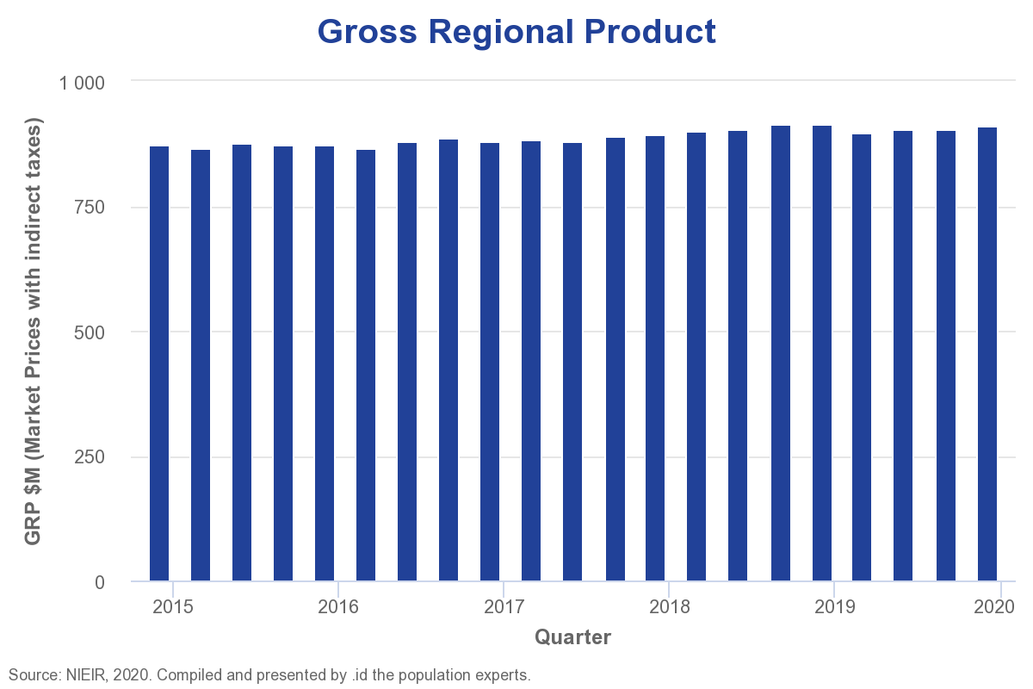
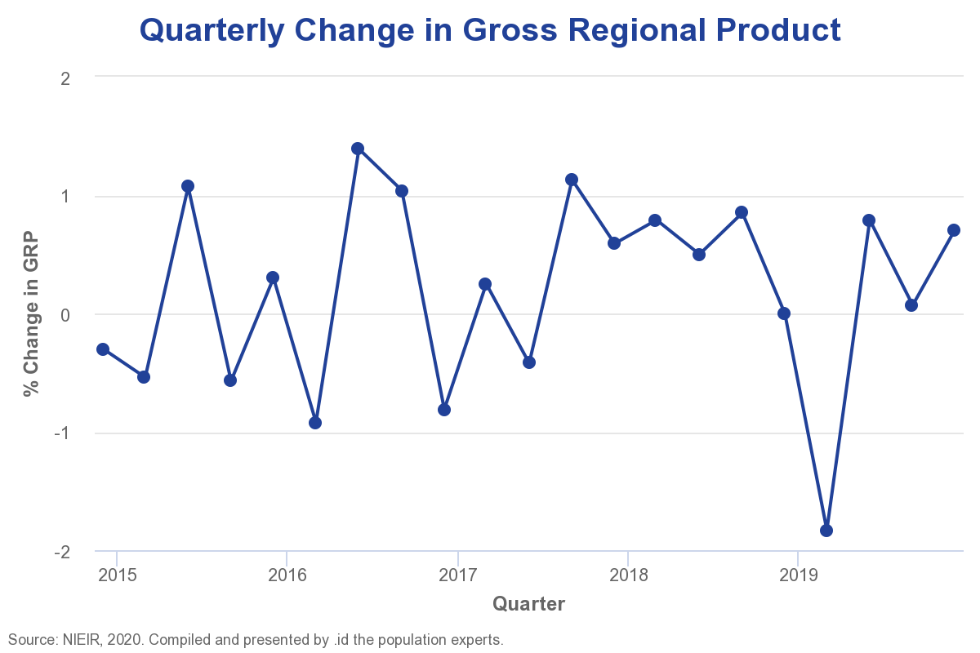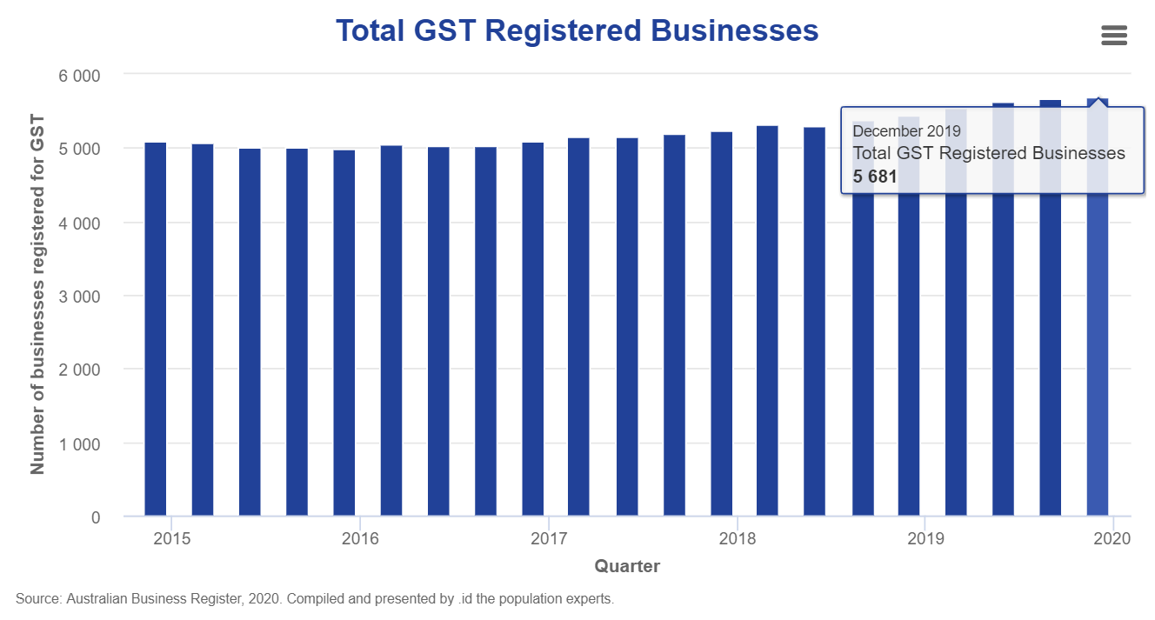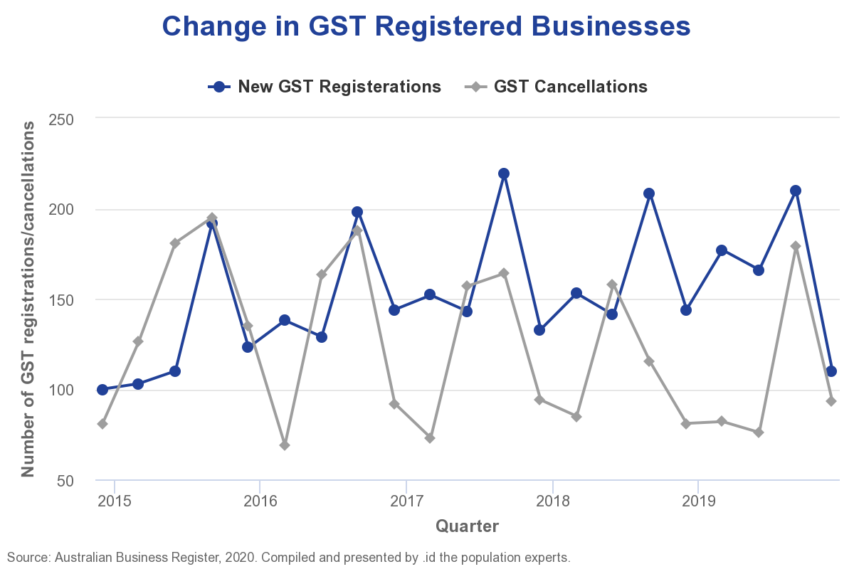

Jobs Activity

KEY INSIGHTS
- Local Jobs grew in the December 2019 quarter with an estimated average of 34,639 jobs in the LGA, up 1.5% from the September quarter.
- The number of jobs is up 582 (1.7%) from the same quarter last year.
- Online job vacancies decreased in the NSW North Coast region in the December 2019 quarter by 21.9%, and were down on the same quarter the year before (-15.1%).
- The smallest quarterly decline occurred in SALES WORKERS (-16.1%).

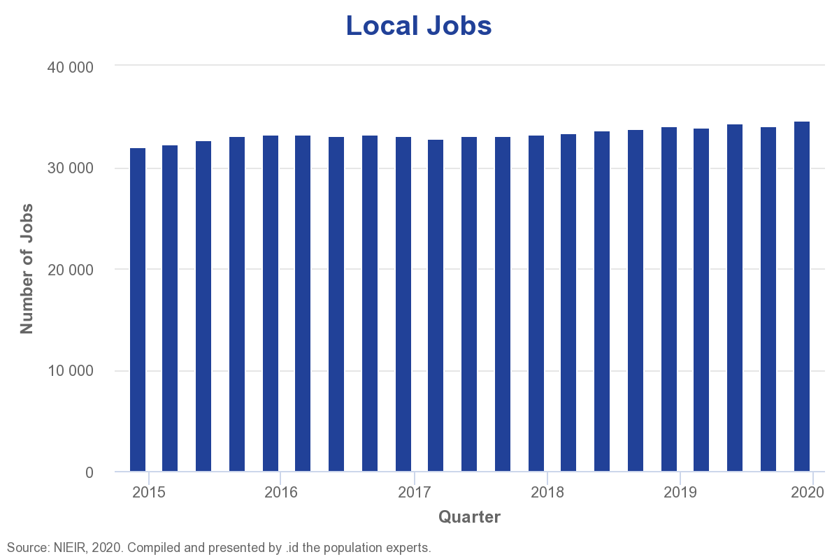
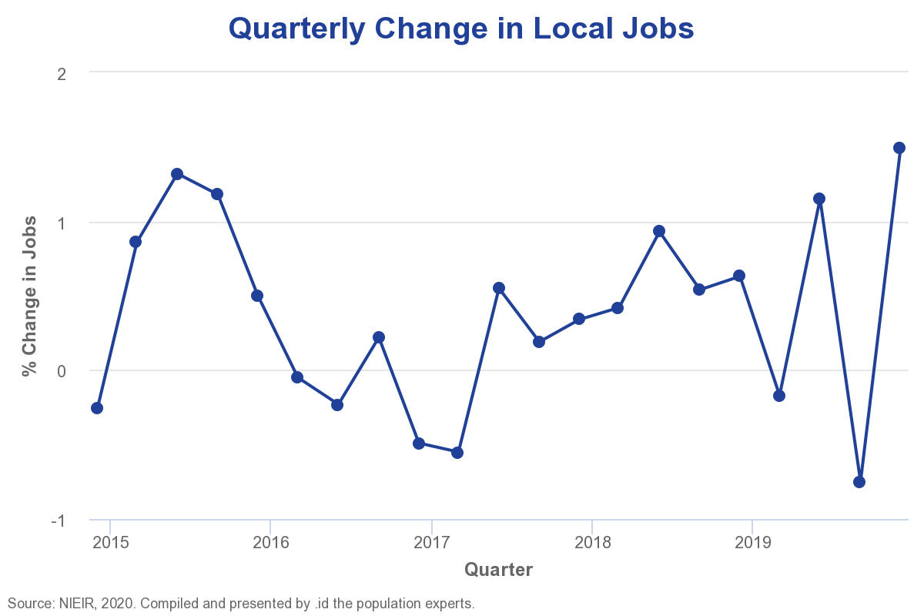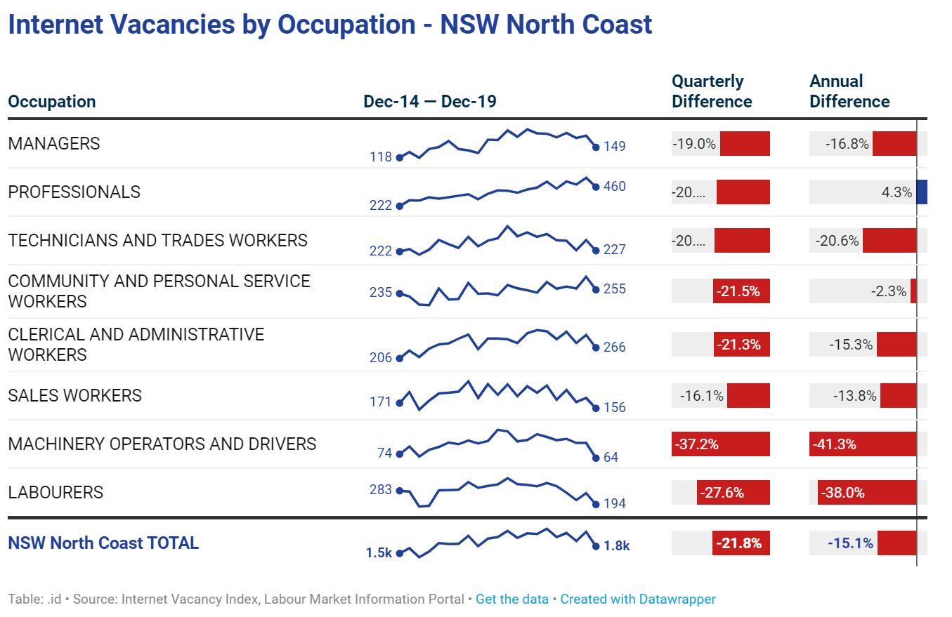

Labour Market

KEY INSIGHTS
- The unemployment rate in the City of Coffs Harbour* decreased in the December 2019 quarter to 5.0%. It is now only slightly higher than the Regional NSW average (4.7%).
- The unemployment rate has decreased by 3.3 percentage points over the year.
- The resident labour force increased by 298 (+0.8%) in the December 2019 quarter and but decreased substantially over the year.
- It is important to note that the completion and commencement of large construction projects can cause swings in unemployment rates in small areas.

*Small area labour force estimates should be viewed with a high level of caution due to the variability involved in extrapolation of small sample sizes
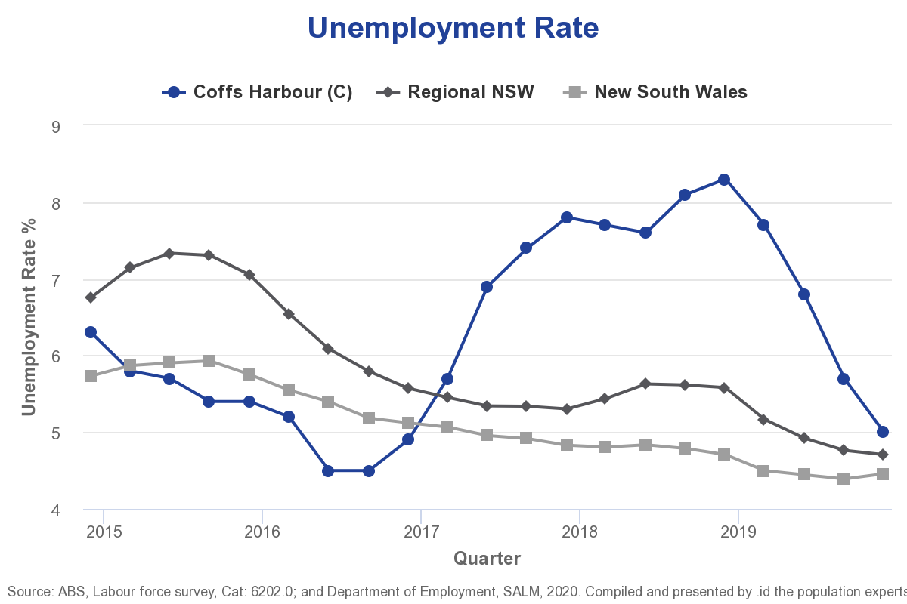
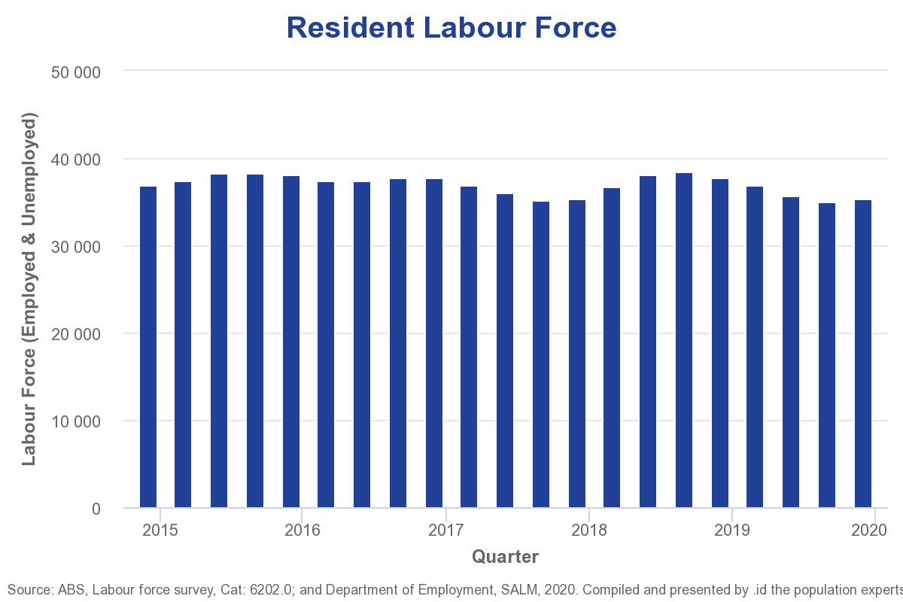

Investment Pipeline

KEY INSIGHTS
- The value of building approvals in the December 2019 quarter was down from the September quarter (-$10.4M, -25.0%) to $31.3M. It was mainly driven by a decline in the value of Non-residential Buildings approvals.
- The value was also much lower (-82.9%) than that experienced in the same quarter the year before.
- Non-residential approvals was led by the Private Sector, mainly by Other non-residential buildings.
- The majority of non-residential development in the FY to date has been in the Coffs Harbour - South area ($9.4M)
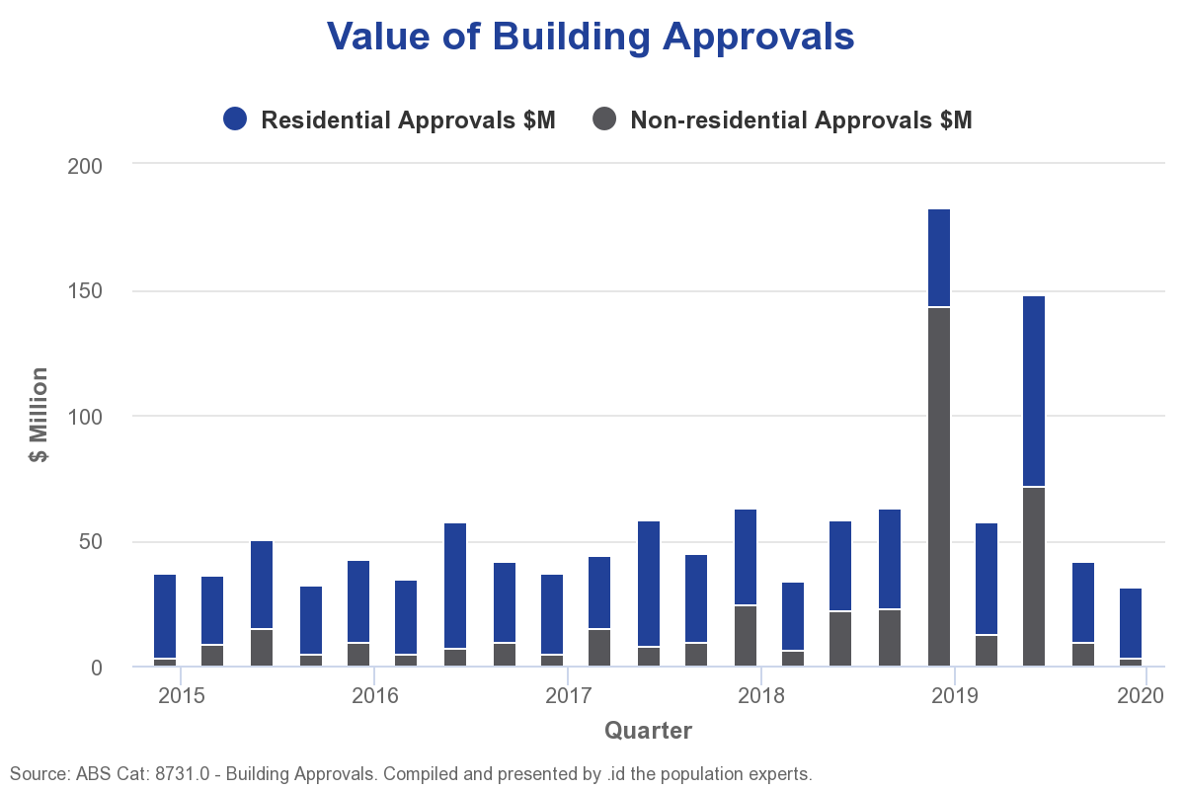
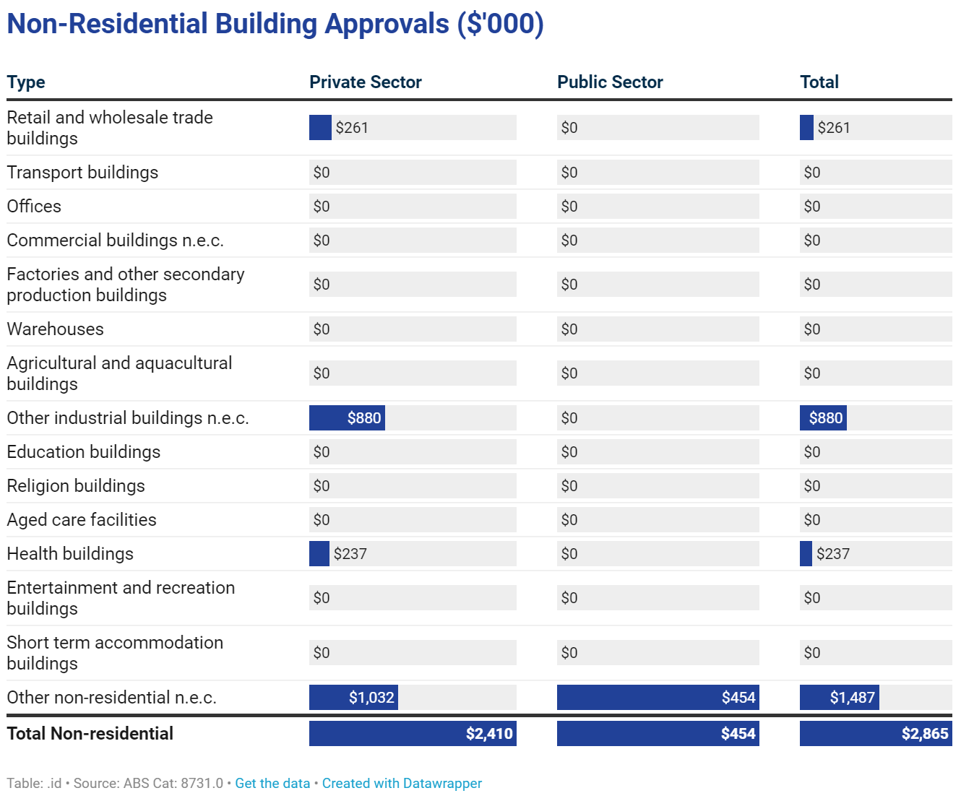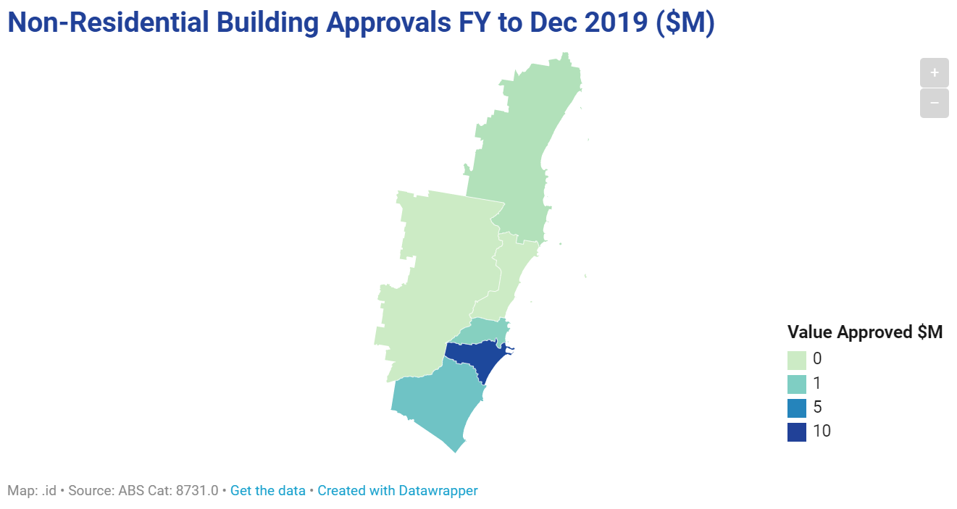

Visitation

KEY INSIGHTS
- Visitation to City of Coffs Harbour was down (-71,852; -14.1%) in the December quarter compared to the previous quarter, but was up on the same quarter in the previous year (+5.3%).
- Domestic visitation decreased in the December quarter with day-trippers falling by 44,963 (-17.7%) and overnight visitors by 26,889 (-10.5%).
- International visitation increased (+5,290, +22.7%) and was also up from the same quarter the year before (+20.5%).
- Total nights stayed by visitors increased from the previous quarter (+18.6%) and was also up from the same quarter in 2018 (+42.5%). The average length of stay in the quarter was 3.0 nights for domestic visitors and 14.3 for international visitors.
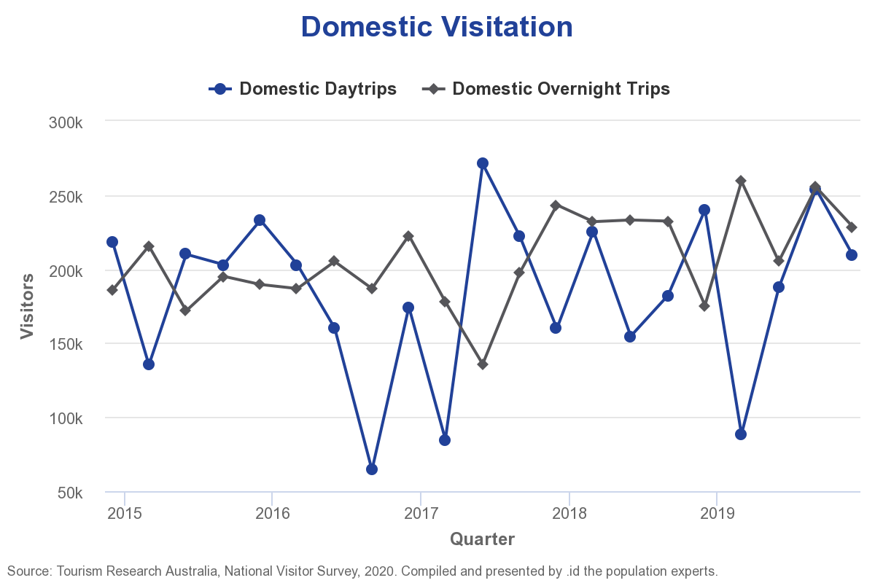
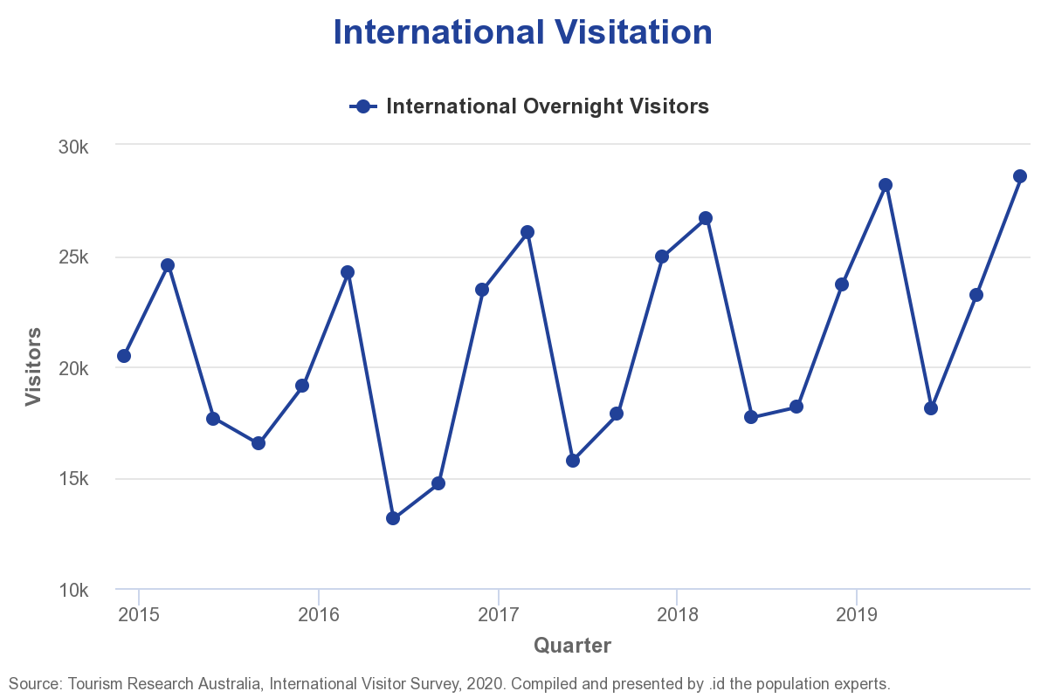
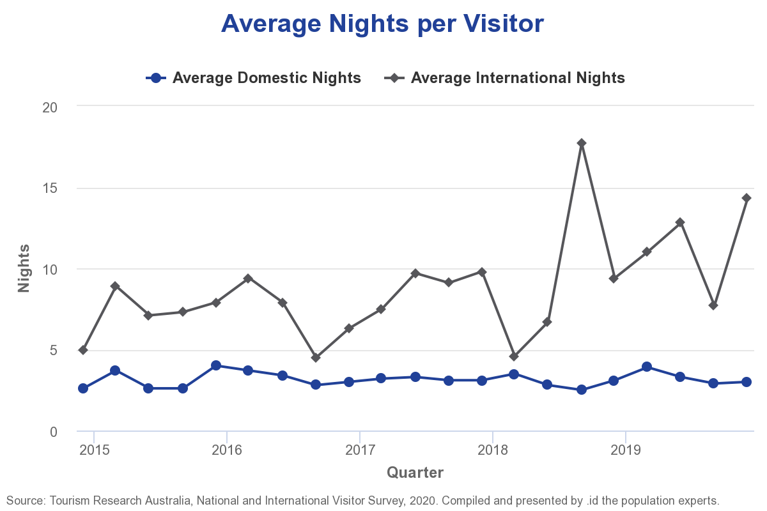

Housing Market

KEY INSIGHTS
- Building approvals for new residential dwellings fell by 7 in the December 2019 quarter from that experienced in the September quarter. The figure of 82 approvals was lower by 10 than that achieved in the same quarter the year before.
- The median dwelling price in City of Coffs Harbour decreased by $20,000 in the September quarter* to $500,000. This decrease was in contrast with a rise in the Regional NSW median price experienced during the same period.
- The median dwelling price was $23,000 higher than the year before
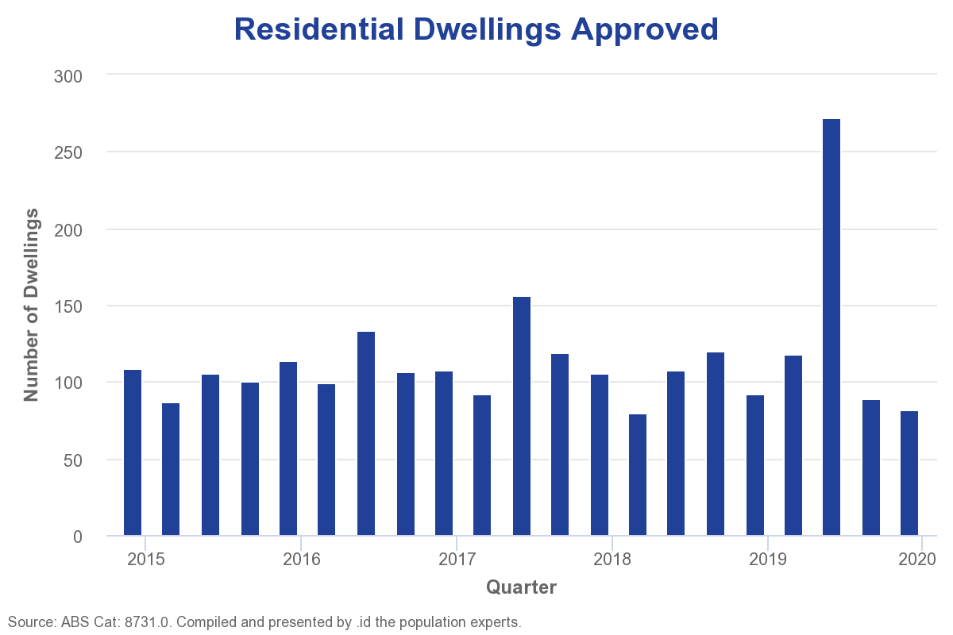
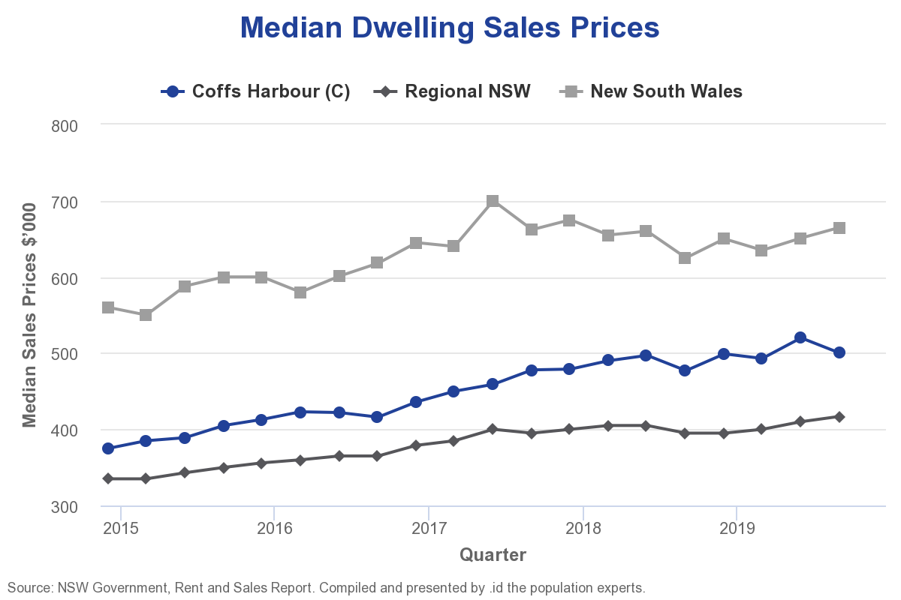

Macro Landscape

KEY INSIGHTS
- City of Coffs Harbour's economy will inevitably be influenced by a number of macro forces that are outside its control. Tracking key state and national indicators will identify trends that could impact future local prosperity.
- Economic growth at the national level in the December quarter was down marginally from the last quarter but slightly higher than the December quarter in 2018. The unemployment rate was down in the December quarter to 5.1%.
- Economic growth at a state level was unchanged.

